Salesforce Service Cloud
Salesforce Service Cloud is a customer relationship management (CRM) platform for customer service and support.
This document explains the steps needed to create a Salesforce Developer Account to enable API. Following parameters are needed to configure Salesforce service cloud data connector -
- SaleforceUser
- SalesforcePass
- SalesforceConsumerKey
- SalesforceConsumerSecret
- SalesforceTokenUri - https://login.salesforce.com/services/oauth2/token
- SalesforceSecurityToken
This document provides steps to collect each parameter.
Setup salesforce developer account
- Go to the signup page. https://developer.salesforce.com/signup
- Fill in all the details. Note down the username (SalesforceUser). It will be of form (name@yourcompany.com)
- Check your email to verify the account. In the email there’ll be a unique url for login.
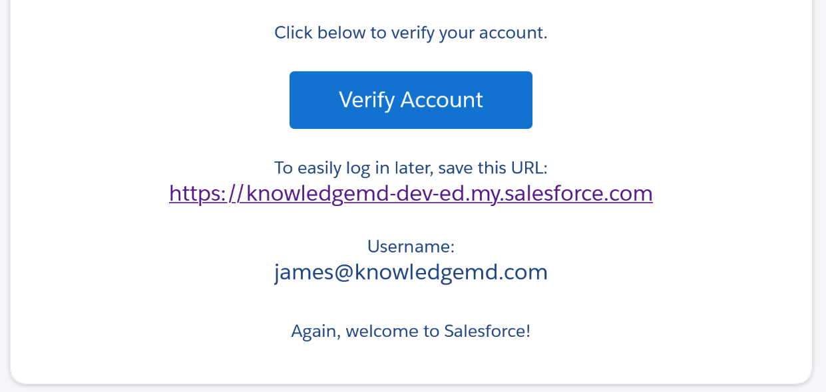
- Complete the signup by providing the password. Note down the password (SalesforcePass).

Confirm that you have “API Enabled” Permission
- Go to Setup. Enter Users in the Quick Find box. Select Users tab.
- You’ll see list of all users. Check your Profile. Click on it.
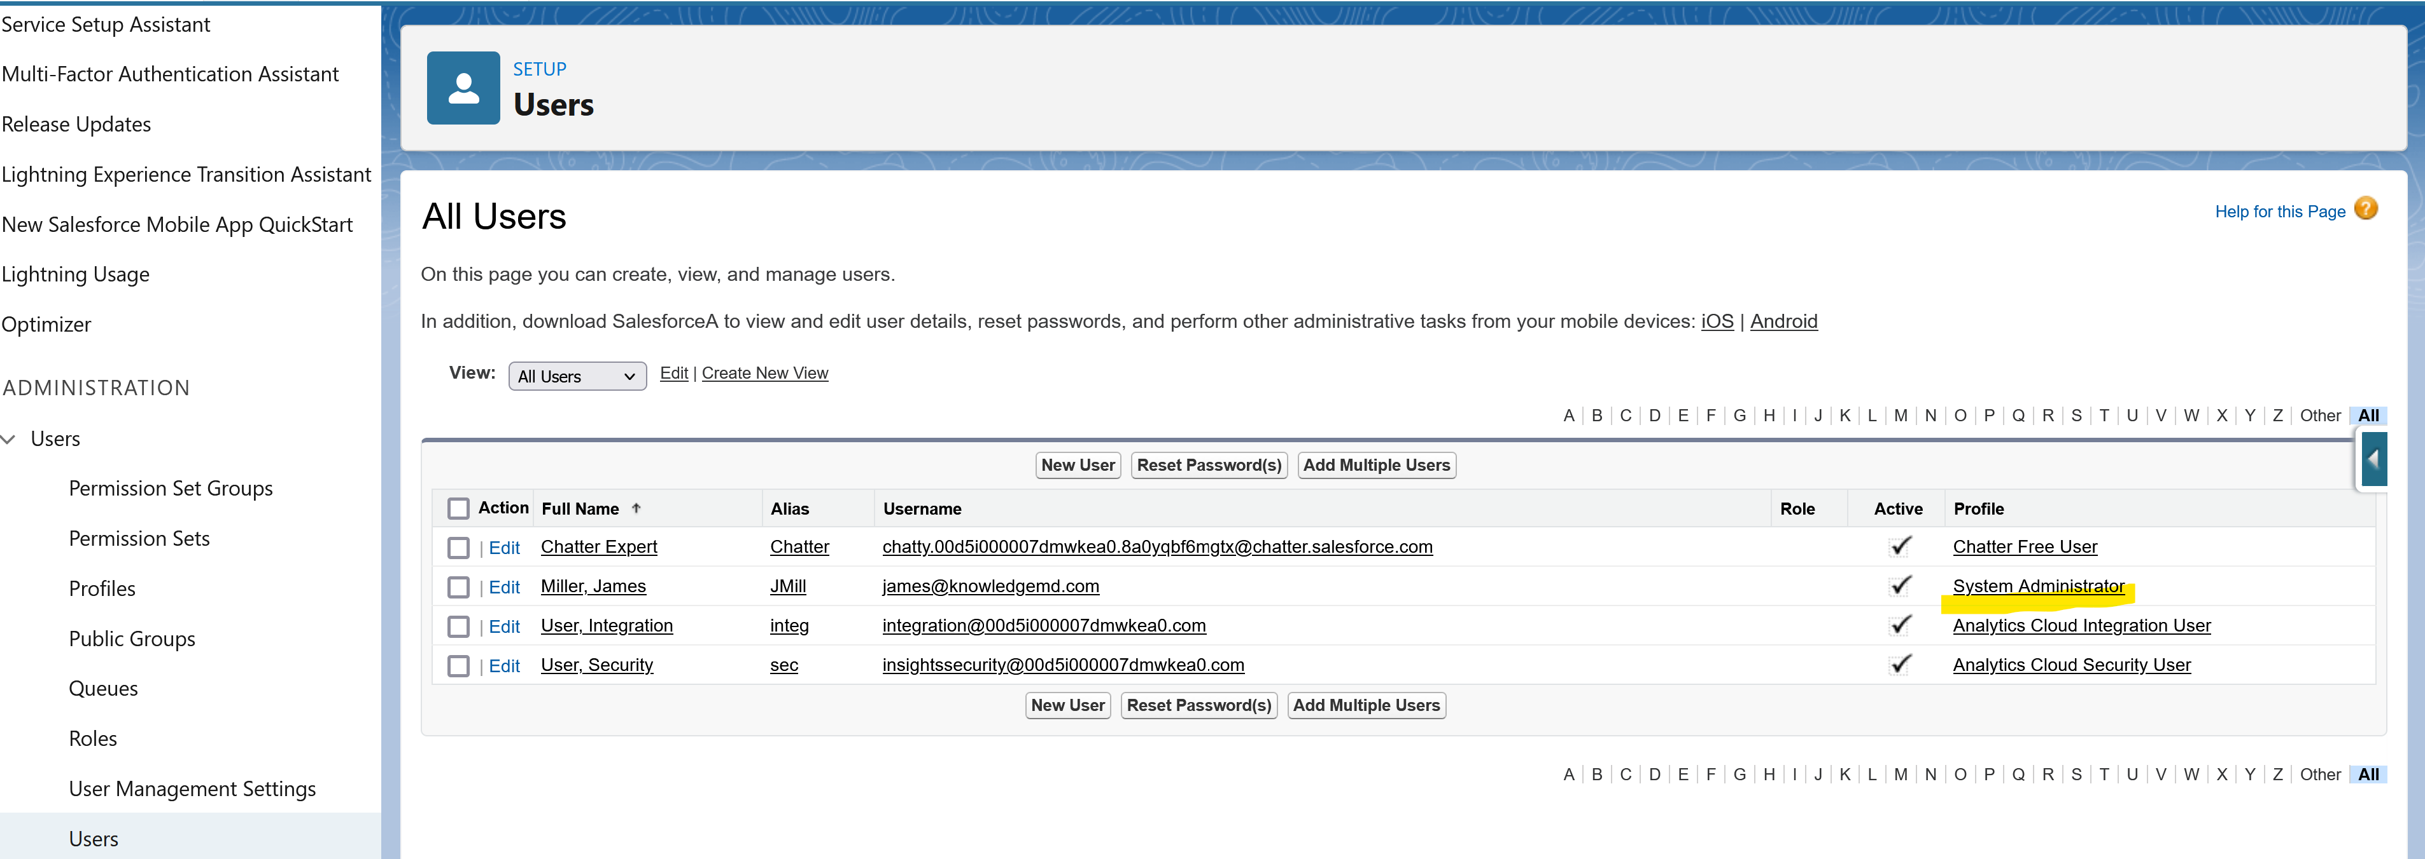
- In the profile page, under “Administrative Permissions”, API Enabled check box should be marked.
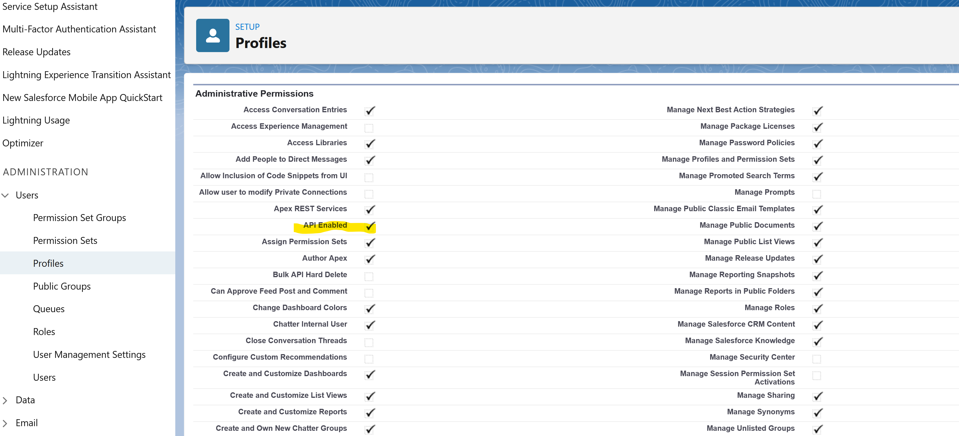

Create a Connected App
- Log in to Salesforce Cloud
- In the drop-down list of the account (in the upper-right corner), select Setup.
- In the left-hand pane, go to App Setup > Create >Apps.
- In the Connected Apps pane, click the New button.
- On the New Connected App page, fill the following required fields under Basic Information:
- Connected App Name. For example, Sentinel Integration.
- API name. For example, UCMDB Integration.
- Contact Email.
- Go to API (Enable OAuth Settings) and select Enable OAuth Settings.
- In the Callback URL field, enter https://login.salesforce.com/ or https://localhost If you don’t have callback url configured.
- In the Selected OAuth Scopes field, select Access and manage your data (api), and then click Add.
- Click the Save button to save the new Connected App.
- In the Connected Apps list, find the App that you just created, and then click Manage.
- On the page that opens, click the Edit button.
- Under OAuth policies, select All users may self-authorize in the Permitted Users list, and then click the Save button.
Get the Consumer Key and Consumer Secret of the connected app that you created
- From Setup, enter App Manager in the Quick Find box, and then select App Manager.
- Click the dropdown menu for the connected app that you created and select View.
- If the values for the Consumer Key and Consumer Secret fields are hidden, Click to reveal.
- Copy the Consumer Key (SalesforceConsumerKey) and Consumer Secret (SalesforceConsumerSecret) values and save them for later use in this quick start.

Generate a Security Token
- Log in to your Salesforce account.
- Click the profile avatar and choose Settings.
- Select My Personal Information → Reset My Security Token.
- Check your email for the security token (SalesforceSecurityToken).

Additional Note
If you don’t want to use security token in API request, change "IP Restrictions" to "Relax IP restrictions" setting for your Connected App. Although it’s not recommended.

